Project Status Report 7
Noise and echo cancellation in a teleconference
Date: 27th May 2015

Project Status Summary
Our goal in this project is to appropriately apply noise cancellation in such a way which enables the system to extract only the voice signal removing as much noise as possible for a great teleconference experience.

To complete the project successfully, our project group and tasks are divided into 3 parts: Android group, Theory group and Management group.

The project schedule is perfectly in line with the schedule and we are confident to complete the project within due date. If required, the members are also planning to accelerate the progress by working weekends and extended hours in the next few weeks.

Work Planned till 27th May, 2015
Android Part: Refining our works to implement real time version of the algorithms.

Theory Part: Refining our works to make the design more efficient.

Management Part: Following up the progress of the group and writing the final project report were set as the core responsibility of the management group.

Work Completed till 27th May, 2015
Android Part:
We have tried to implement log-MMSE algorithm in real time and tried to efficiently clean up our codes so that we can deliver it as a working prototype.

Theory Part:
We have mainly worked on fine-tuning our previous weeks work and implement it in real time.

Management Part: Every members work progress was monitored and followed-up as required to finish everything within the set timeline and integrated to the progress report. We are also working to finish the final report within the deadline.

Risk Analysis
The update of the risk analysis remains as the one in the project plan (see the table below).

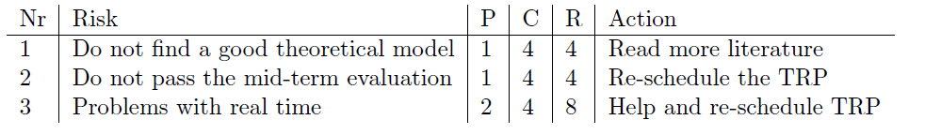
As per the above table, the risk number 1 & 2 are less likely to affect our project outcome because we have good theoretical model with good performance and we have already completed all the 7 android tasks assigned for the mid-term evaluation.

Currently our main concern is the third risk factor, which might take a lot of time, but we are working hard to eliminate this risk factor as much as we can.

Key Performance Indicators (KPI's)
To have a better understanding of the progress of the project the Gantt chart and the working hours of every individual compared to resource allocation table is attached as annexures below:

